Identities inspired by Ramanujan Notebooks, part II and III

by Simon Plouffe
April 2006
Revised December 5, 2009
Abstract
These are new findings related to the ones found in 1998. I had the idea that maybe the sums in the first note I wrote were looking in the bad direction. They are good yes but maybe there is better. Actually there is, instead of considering powers of $e^{2π}$ I should consider powers of $e^{kπ}$.
After a few experiments with Maple (computer algebra system) and PSLQ (integer relations algorithm) here are the findings and remarks. The results were first announced in April 2006 and later in June 2009. There is a new formula for the Catalan constant (K).

- I could go up to $ζ(39)$ and powers of $e^{30π}$ after that the numbers are too close together for any computation, $e^{-30π}$ is of the order of 10⁻⁴⁰ and even with 2000 decimal digits I get an error.
- The powers of $e^{kπ}∓1$ are related to the divisors of a number.
- The numbers that appear to be expressible are so far : log(A) where A is an integer or simple algebraic like $arccosh⁡(\frac{1}{2})$ or $arctanh⁡(\frac{2}{3})$, $ζ(2n+1),$ $π^{n}$, $ζ(2n+1)$ and some formulas involving $lnΓ(1/4)$ and $ln(π)$ but not separately.

Formulas for odd powers of π and ζ(2n+1)
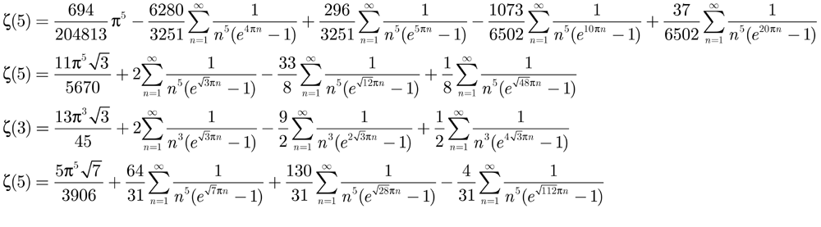
That one is the fastest converging series so far with 5.45 digits for each n.
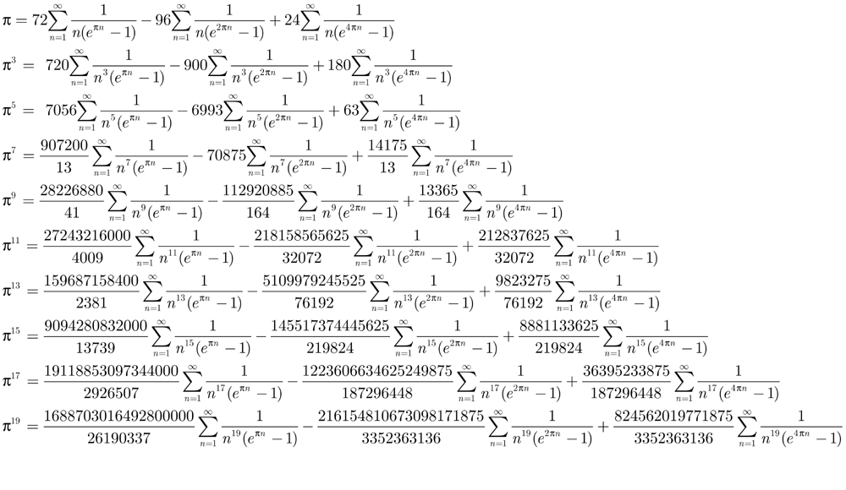
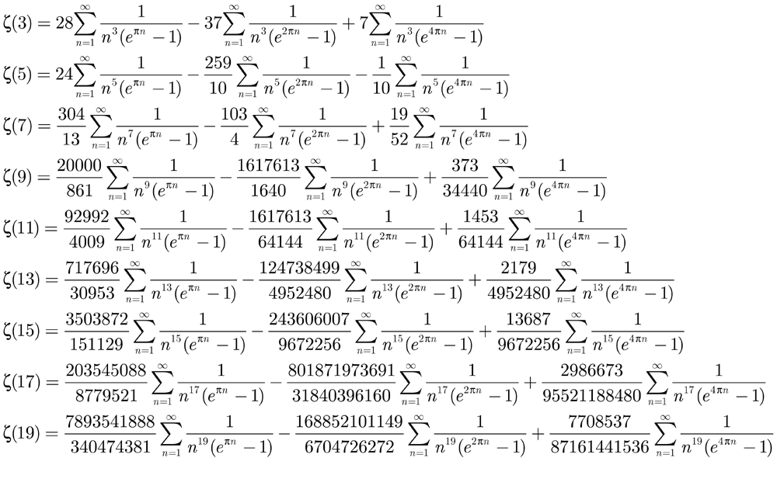

Other formulas
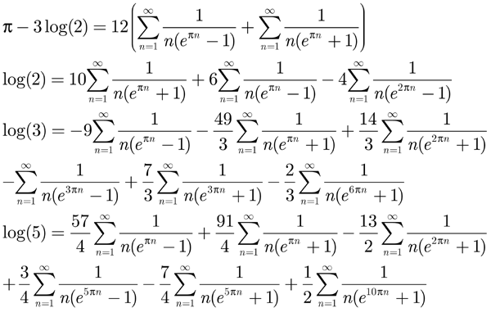

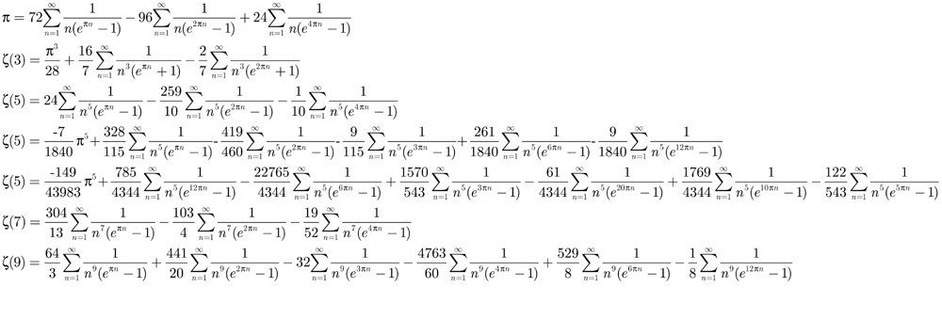

Results of June 2009
Je présente ici une série d’identités inspirées des Notebooks de S. Ramanujan. C’est le 3ème article de cette série, des résultats avaient été publiés en 1998 et 2006. Une nouvelle série pour la constante de Catalan a été trouvée impliquant la fonction $\cosh\left(kπn\right)$ avec k variant de 1 à 4, et qui permet de calculer rapidement cette constante.
Un motif général peut être dégagé de ces identités. En effet, le motif (1,2,4) revient constamment. Une autre remarque concerne un changement de variable avec $e^{πn}$, G.H. Hardy (collected papers) remarquait que si F(x) = $\prod_{n=1}^{∞}{\frac{1}{1-x^{n}}}$ alors en posant x=$e^{π}$ on retrouve plusieurs identités sous forme de produit infini plutôt que de somme, le log d’un produit infini est une somme infinie. La fonction F(x) n’est autre que la fonction partages de n, largement étudiée par Hardy et Ramanujan.
I present here a series of identities inspired from Ramanujan notebooks, third of a series from 1998 and 2006. A new identity for the Catalan constant involving $cosh⁡(πn)$ is given, giving a relatively rapid convergent series for that number. A general motif with exponents 1,2,4 always occur. A new series of approximations is also presented with incredible precision.

$$\frac{1}{π}=8\sum_{n=1}^{∞}{\frac{n}{e^{πn}-1}}-40\sum_{n=1}^{∞}{\frac{n}{e^{2πn}-1}}+32\sum_{n=1}^{∞}{\frac{n}{e^{4πn}-1}}$$
$$π=72\sum_{n=1}^{∞}{\frac{n^{-1}}{e^{πn}-1}}-96\sum_{n=1}^{∞}{\frac{n^{-1}}{e^{2πn}-1}}+24\sum_{n=1}^{∞}{\frac{n^{-1}}{e^{4πn}-1}}$$
$$\frac{π}{24}=\sum_{n=1}^{∞}{\frac{1}{n}\left(\frac{3}{q^{n}-1}-\frac{4}{q^{2n}-1}+\frac{1}{q^{4n}-1}\right)}, q=e^{π}$$
$$\frac{1}{π^{2}}=2\sum_{n=1}^{∞}{\frac{n^{2}}{\cosh\left(πn\right)-1}}-32\sum_{n=1}^{∞}{\frac{n^{2}}{\cosh\left(2πn\right)-1}}+32\sum_{n=1}^{∞}{\frac{n^{2}}{\cosh\left(4πn\right)-1}}$$
$$π^{2}=120\sum_{n=1}^{∞}{\frac{n^{-2}}{\cosh\left(πn\right)-1}}-420\sum_{n=1}^{∞}{\frac{n^{-2}}{\cosh\left(2πn\right)-1}}+120\sum_{n=1}^{∞}{\frac{n^{-2}}{\cosh\left(4πn\right)-1}}$$
$$2K= 22\sum_{n=1}^{∞}{\frac{n^{-2}}{\cosh\left(πn\right)-1}}-71\sum_{n=1}^{∞}{\frac{n^{-2}}{\cosh\left(2πn\right)-1}}+22\sum_{n=1}^{∞}{\frac{n^{-2}}{\cosh\left(4πn\right)-1}} , avec K=Cte de Catalan$$
$$1=24\sum_{n=1}^{∞}{\frac{n}{e^{πn}-1}}-96\sum_{n=1}^{∞}{\frac{n}{e^{2πn}-1}}+96\sum_{n=1}^{∞}{\frac{n}{e^{4πn}-1}}$$
$$1 = 24\sum_{n=1}^{∞}{\frac{n^{3}}{e^{πn}-1}}-264\sum_{n=1}^{∞}{\frac{n^{3}}{e^{2πn}-1}}$$
$$1 = 4\sum_{n=1}^{∞}{\frac{n^{7}}{e^{πn}-1}}-484\sum_{n=1}^{∞}{\frac{n^{7}}{e^{2πn}-1}}$$
$$1 =\frac{63}{1382} \sum_{n=1}^{∞}{\frac{n^{11}}{e^{πn}-1}}+\frac{131103}{1382} \sum_{n=1}^{∞}{\frac{n^{11}}{e^{2πn}-1}}$$
$$1 =\frac{1}{7234} \sum_{n=1}^{∞}{\frac{n^{15}}{e^{πn}-1}}-\frac{32641}{7234} \sum_{n=1}^{∞}{\frac{n^{15}}{e^{2πn}-1}}$$
$$ζ(4) =14\sum_{n=1}^{∞}{\frac{n^{-4}}{\cosh\left(πn\right)-1}}-\frac{259}{4}\sum_{n=1}^{∞}{\frac{n^{-4}}{\cosh\left(2πn\right)-1}}+\frac{7}{2}\sum_{n=1}^{∞}{\frac{n^{-4}}{\cosh\left(4πn\right)-1}}$$
$$ζ\left(5\right)=24\sum_{n=1}^{∞}{\frac{n^{-5}}{e^{πn}-1}}-\frac{259}{10}\sum_{n=1}^{∞}{\frac{n^{-5}}{e^{2πn}-1}}-\frac{1}{10}\sum_{n=1}^{∞}{\frac{n^{-5}}{e^{4πn}-1}}$$
$$\log\left(2\right)=16\sum_{n=1}^{∞}{\frac{n^{-1}}{e^{πn}-1}}-24\sum_{n=1}^{∞}{\frac{n^{-1}}{e^{2πn}-1}}+8\sum_{n=1}^{∞}{\frac{n^{-1}}{e^{4πn}-1}}$$
$$\log\left(3\right)=\frac{76}{3}\sum_{n=1}^{∞}{\frac{n^{-1}}{e^{πn}-1}}-\frac{112}{3}\sum_{n=1}^{∞}{\frac{n^{-1}}{e^{2πn}-1}}-\frac{4}{3}\sum_{n=1}^{∞}{\frac{n^{-1}}{e^{3πn}-1}}+ \frac{28}{3}\sum_{n=1}^{∞}{\frac{n^{-1}}{e^{4πn}-1}}+\frac{16}{3}\sum_{n=1}^{∞}{\frac{n^{-1}}{e^{6πn}-1}}-\frac{4}{3}\sum_{n=1}^{∞}{\frac{n^{-1}}{e^{12πn}-1}}$$
$$\log\left(∅\right)=11\sum_{n=1}^{∞}{\frac{n^{-1}}{e^{πn}-1}}-14\sum_{n=1}^{∞}{\frac{n^{-1}}{e^{2πn}-1}}+3\sum_{n=1}^{∞}{\frac{n^{-1}}{e^{4πn}-1}}+ \sum_{n=1}^{∞}{\frac{n^{-1}}{e^{5πn}-1}}-10\sum_{n=1}^{∞}{\frac{n^{-1}}{e^{10πn}-1}}+20\sum_{n=1}^{∞}{\frac{n^{-1}}{e^{20πn}-1}}$$
$$1-\frac{1}{π} =16\sum_{n=1}^{∞}{\frac{n}{e^{πn}-1}}-56 \sum_{n=1}^{∞}{\frac{n}{e^{2πn}-1}}+56 \sum_{n=1}^{∞}{\frac{n}{e^{4πn}-1}}$$
$0=[1,2^{k-1}+2^{k/2}+2^{2}, 2^{k}$] $≡$ $\left[a,b,c\right]$with k = 4,6,8,…
$$0 =\sum_{n=1}^{∞}{\frac{n^{k}}{cosh⁡(πn)-1}}-(2^{k-1}+2^{k/2}+4)\sum_{n=1}^{∞}{\frac{n^{k}}{cosh⁡(2πn)-1}}+2^{k} \sum_{n=1}^{∞}{\frac{n^{k}}{cosh⁡(4πn)-1}}$$
$$π^{3} =360\sum_{n=1}^{∞}{\frac{n^{-3}}{\sinh\left(πn\right)}}-90\sum_{n=1}^{∞}{\frac{n^{-3}}{\sinh\left(2πn\right)}}$$
$$π^{5} =3528\sum_{n=1}^{∞}{\frac{n^{-5}}{\sinh\left(πn\right)}}-\frac{63}{2}\sum_{n=1}^{∞}{\frac{n^{-5}}{\sinh\left(2πn\right)}}$$
$$2K-ζ(2)= 2\sum_{n=1}^{∞}{\frac{n^{-2}}{\cosh\left(πn\right)-1}}-1\sum_{n=1}^{∞}{\frac{n^{-2}}{\cosh\left(2πn\right)-1}}+2\sum_{n=1}^{∞}{\frac{n^{-2}}{\cosh\left(4πn\right)-1}} avec K =Cte de Catalan$$

Results of April 2006
Here is a table of results with the coefficients :
Results with$ζ(z)$, $π^{z}$,$S\left(z,1\right), S\left(z,2\right), S(z,4)$ where $S(k,m)$ is
$$\sum_{n=1}^{∞}{\frac{1}{n^{k}(e^{mπn}-1)}} = S(k,m)$$
The display is the integer relation that makes the vector [$ζ(z)$, $π^{z}$,$S\left(z,1\right), S\left(z,2\right), S(z,4)$] equal to 0.
3, [1, 0, -28, 37, -7]
5, [-10, 0, 240, -259, -1]
7, [-52, 0, 1216, -1339, 19]
9, [27930, -1, 39680, 16401, -221]
11, [-538116, 2, -1108992, 33843, -1083]
13, [-4616430, 2, -27095040, 17859891, 2289]
15, [52761192, -2, 100614144, 4902099, 6141]
17, [-2381720400, 8, 2954035200, -7717548915, 72915]
19, [39005722340, -14, -1613496320, 79624947155, -6155]
21, [-221481750994700, 6732, 850750073733120, -1293713997563111, 421840591]
23, [1226556695374, 9, -84963147907072, 87416281554613, -20256793]
25, [5203911059453925, -1921, -1567010009907200, 11974832749256745, -620441695]
27, [8148451902123610, -306, -1701430826106880, 17998334655707395, -25353295]
29, [-13964212268709884725, -140282, 1170802376844509184000, -1198730801485834158745, 103905205295]
31, [-54171522182777606620, 20123, 56675100822926786560, -165018145241264800615, 52782800815]
33, [-58909621176539933053170, 2545893, -131688610996976101621760, 13869368616464330113914, 27431905401506]
Results with Zeta(z), S(z,1), S(z,2), S(z,4).
The display is the integer relation that
make the vector [Zeta(z), S(z,1), S(z,2), S(z,4)] equal to 0.
3, [1, -28, 37, -7]
5, [-10, 240, -259, -1]
7, [-52, 1216, -1339, 19]
9, [34440, -800000, 869253, -373]
11, [-64144, 1487872, -1617613, 1453]
13, [-4952480, 114831360, -124738499, 2179]
15, [-9672256, 224247808, -243606007, 13687]
17, [-95521188480, 2214570557440, -2405615921073, 2986673]
19, [87161441536, -2020746723328, 2195077314937, -7708537]
21, [-511417392598515200, 11856658470320209920, -12879494224969023401, 969451783081]
23, [-809054768954368, 18757052482453504, -20375166492392041, 4472029801]
25, [-9402626177680619520, 217989612878618951680, -236794866356583343203, 1122603152483]
27, [-433559729330180096, 10051608326929645568, -10918727935370641697, 149780635937]
29, [70591765772239009938104320, -1636592903864970323479756800, 1777776435935195869731249349, -525747526375283909]
31, [-520167571795410350915584, 12059516381224761076744192, -13099851536046881623355143, 11231299844779783]
33, [-10652244887519367873408902922240, 246960650058691978789414796001280, -268265139838691529135407355836517, 4960814599174753990757]
35, [-2732942456837303169145438208, 63360282530610722654381932544, -68826167447973382833596090501, 3688053840923281541]
37, [-1424192973610401074580480646493634560, 33018356811066418402946396259121889280, -35866742758328669027445599763623152661, 41448475338242211513994261]
39, [31536188043819957788458947444736, -731132036585425088557545661923328, 794204412675724846988747136207187, -2659842854283579394387]
41, [12773377697620891851198465395561679146188800, -296136794882949433788107046141906375032176640, 321683550278214452268691394539562438746427097, -23234778187417606532705421872857]
43, [233097371723978108279933298059247616, -5404107683343089621820512227764994048, 5870302426792274590206831552234790117, -1228751826452728351300837]
45, [140600817767916545581693183361009315526861326909440, -3259676220131698228640954778884807655906629501583360, 3540877855667547304242700329643553467180817656754611, -15984438359184036727180220465501352371]
47, [2254919587126878277155357568098096977543168, -52277844988066489224430209234308641738194944, 56787684162320988691600873634610990609888551, -742912859949264106154916607271]
49, [284524049801951474153643015128700095967174408724807680, -6596378982132770562246518166744835627859463792649830400, 7165427081736675532219530224305149732457982689130518611, -2021665726027302913912664170079031072851]
51, [12213435551464851306588720257503511850254336, -283155148492348076155312278372927288186503168, 307582019595278030260782036775946315366307047, -251492292317888012003479295207]
53, [130137454758409843860165531701040966161594385248587486330880, -3017094589909565702616435024906390294964042473906645824962560, 3277369499426385448129400121915923378120436526114126848209189, -57792634033607451150833205281710306050584869]
55, [-19787331441001612103854548589972560860344628543488, 458747643022697229679034253322268753530821000822784, -498322305904700479352353139318239295763736705069711, 25465609788816025420512226447159951]
57, [-8229610565782363379309230843178332823243893220736032646620365455360, 190794522308574764832610713856918040956153313967530080944929405665280, -207253743440139491819646759246409433120794643349962120562288056908221, 228417583703134726518153542940959974324117920332221]
59, [31760943205719479335823285328215456670357182181431056531456, -736342739254385809841346747190949908172635592872774271500288, 799864625665824771067695390146684566835478274489741411197277, -2554702072299303745322128317254105026634077]
61, [11228750712595691857993899010018102022037871254939583265845661500073574400, -260326307205776478317777039351824473045960872891225249332788909477388615680, 282783808630967862053243614724676254536783858288976645470904467362872436199, -19478777352815577446747242887872229606424234885336671719]
63, [-4420734755976561477819352219602229305413295023063050334765056, 102489901469508664033765456187485011871537248089030410809376768, -111331370981461787011628115392902787866895877725893259127542497, 22223954766213317384532039590736747648635617]
65, [-8683784727375452650614759128937062365289209832692753414899240041785839908290560, 201324053628847266745608051881163101313191326264291637750219224169082169579274240, -218691623083598172047779067967099055178898618094875773172951473280049980872394819, 941497828061829135128872165198628592933769027396131476539459]
67, [-14974422008672519045548749269274479895709052562995131254761848832, 347165600504945911039907687335075786243749800574965856300859129856, -377114444522290949135710157102120959683567879802427217434372529149, 4704971228496213648399974101471098623989701629]
69, [-185314968362017705213459062217245680311133697058676732436818759208189611338841184010240, 4296324909014516204385185193530987448037813346593314121138374551245928228542091152588800, -4666954845738551614813359061035594749614058479585029726717416648664601047412933868051203, 1255743070115940953977738874362140705404579002293596193160347441923]
71, [61765379767975943763564298671677357518170611735643783882563340122256733896704, -1431962792630438802123000716647117309276993835203533818855166566376154911997952, 1555493552166390689651342233655072283397499596396297454512791444169473685730933, -1212919664600259084164537721476067892498197548805305939573]
73, [24938099006978845638493179864064412055475176319643422932932502097890221096955660601267322880, -578162556938456821207869671616593770935223736916678380623777686489311432178114313091557621760, 628038754952414512484866593040473963109200116123894385538012001016336947709809541332345736249, -10561695751368063026026567929159048369310331245073337783907038253468729]
75, [-390204487785772245552169373144049299002675650800864945178530088720281894912, 9046464380622959539308570407853288465993852509926942216097125384641855881216, -9826873356194504030413388069978046446128816575369031099273417647506967481289, 478915836659382129612763840358992819232085424547810249]
77, [33039031803780971646949418274018429138835113108412595794105156149033692062506396416263621777786142720, -765973825875797056544315681412317221875941036687818278628814248110123988836413433976388600828012789760, 832051889483358999838215392496244159658913985805066846948699934993472641291634017861906619893964508777, -874535890079505302722900423376731675374585281268330207791052990775510379433577]
79, [-7948573908706841534676092247545401116795900549084783397826629754111252014199698620416, 184278994713518335994789403080017025025990349547503367528394518575528037349365821472768, -200176142530932019064142197303154738396565412442419820990606363048408446558455160474447, 609728046911136983261796746886666558584964657905180689941760847]
81, [2504310589755493072033404099474008766889806532267901542178442869871759832765575608026779319275662085822873600, -58059702687678837992904172486551067085554170734728242382229349511158799691722489501521984579816048690032803840, 63068323867189824136970984828533419957022955083560281658006829607403557849050730415902260092229677419061847917, -4143034335337689171284296236191420594356501238491797089698326716873862304557383296877]
83, [-1395026488446729377451315071249881234067003497677540212504033354616854984062500885760049152, 32342163744378698719941090436550869833177196878205557958055175630121978659907869773928595456, -35132216721272157474843727267253336642684999570713820055790394625517711935315503090798526799, 6688202704341373795697153181672727152286162023307282631545349833039]
85, [121834497350173728318760510741188576953548165930928245410766168786624862797993941252308201151758207273972877230080, -2824599601259728750686995912605218413540431435651911040392709005764727911440879191392092816100292157242659171205120, 3068268595960076207324516946684987335955360566222912476729629534499825775961375644019214528685521313367393538495207, -12597391768507832798709144945515388191161848138924508570122505310281712741576788612829927]
87, [19987577845270390472333484509168881791283688521932190774797721782573154748703807062087127007232, -463390136946446960482794719798163922150023456255553446904699367701772368255311232229966511865856, 503365292636987741427461694805678831519987364417154860763793978244275335656845323444057212840399, -5989177145787396531117737032309499166977356657904126477089916446960079]
89, [-11382117140085825344388010664609015374285519312312917282482536944004293264331882522495597719244213824649373936999297187840, 263881940128775051515996279378134951586121054780315800597831250209783986449098272472927097491332545067810091221960255078400, -286646174408946702204772300780908190366644265495400093696686323143306140300716829134579716140753227988482849620673360747903, 73555208031952172090458458533889999045513567322954791616661423210932255271374010524714511293823]
91, [1522102149490661104692353150683889113184002478291883954809768441239186413856991721498790709479797161984, -35288273994933232485916603409966853301095862799681426584759584410796993537976853479539612667235576840192, 38332478293914554695301309739840272249209910983298299400567223489653685161026294986622032987889620762143, -28505640721746043227033104906188102196378318795335458064084838901694449597983]
93, [-491241796584098093801513455786168313619673947101988037736189133974977583423469763874264174601567675405782707819514255149013, 9602971205724114176441661032518594126103795203741664904588953964555593171392107534391107297007978677705326914518669298738292, 30735077653585262005264092518337151637958462294631864036348466652940038043489268227002700528578448453149334294317101287693358, 3855887201060467794813314593482421805307176414738677915854759562618599349548711551429633075059624382748270074420815607856026]
95, [-52673654030825340292175962658467915662819993918864806578106026195130784352819264976035664886452866573194493952, 1221181072752626302938026487122610613291421157043598899505831940516863985869032018194363278902262562813416308736, -1326528380814276983522378412501200333032446940726844360488172383974157790016379484551078354355314559831909837369, 61653888415385795845515847826128391067032235441708936404643745680146263872104540729]
97, [456364510414326437385692885329843311955447838091850107200649671557377948784823766367805778178813664916797029021868927303217, -10443267668689027599579320122734359006139100166561518160777468720377586339501072469847377838903615374771917413853879389405317, 8205784822378328917683958226933549714084739188875760024899097891051344144656212052476817229825990022513903291071465656504472, -11316027937409660831726488097960791692249310808175202129805052771789724886327638934726813571755642386646111938070680297622299]
99, [-8155244689141447419499275678028996134604225751254697210874866778006303671551717424891658961349146880033746321408, 189070430773945373364910234480616270780118860471770395820007862860130191605543975285496541228248415440837420253184, -205380920152228268203908785837270864134010756753913905817577091508686961213707590513865217055397647954008200549611, 596601084683444779634115575819495092544162265060180378585357904450938753103287653611]
101, [-1554274346397441479432503923086811022876576252166888256451590872704190489115389632727750879307230104170590339219560490821330, 33956109539951654920292462565614977022098845388860600985659194615550241140221285385301146702411685813055542107241178251853270, 11016717056318325203555285106030467252029474415240273554727712214806804598419485114710287964235308576291996992670136150357855, 3191095482244020780607369935557218962513586714375459427428762978640964967057601171890655510443821356053761294742847109979621]
103, [1118824616252685649934065805500145702719461484493459585739567465074894257346035969136797471482612246119200476677275648, -25938725350208855527021822720889075222130762005597312373964115654492993255833638599159511480099565076669087605948678144, 28176374582714226826889954331894482139159696215641678874815017376262537833500068916879975020899681768174515731996583601, -5115511590011241057447329371766791619756062974358379446868597834892199267027172693354161]
105, [-176710837375537193816242358548002715816616876314510188934982163046193017543813702752576463652761090265025033547820207134067, 4133587126218477834598952595118638144396998175685455833678178574144011398834588857104945924874279141552052785497156577822591, -5317916571666089386029817433599380529013528940015974648376589365873582980379497114125406016317853544053925879646619424913526, -10339103646093565843157198391472641859698418134105422347226738703340140847888203934883537370469210381757327017307923172792940]
107, [-368405925295638437222037141558011197109559938049757486928246128085803176236523403788285735920239751540790486101139504385846, 8129559352144475644522725865432736283708608674226550501981527473562701796853359787899102577642841455207707204962890485300412, 646213711272239871177306970701659509022694062986607507621169230487099514291498469133750386256848948794888449449780276427493, 5625461083064419151836355294224799739700680406988346931514477506460187975609157936200669001667740991143693310926233800278618]
109, [606171310404229167000162438730244946541623366625293588945808661752526980388523594299811481436566342489430985994364263656850, -12858490332310573654134288861658687105538374245428572068823729917640832083201340473308943359024949952246360143459037035188791, -13576238875722345225346972567315986396744655167145305276502569793239531682415248852847350572195249016500516958055098754731428, -2363524705816573982526678929534377357401062559018149066745347964351908730958169977255937468569199056208633676248235912509368]
111, [-25037993906775741191501700437801988670760810014291300916810723293008378911790800624156631494065591360832274046962089041291, 177251981931029916150008413027835267944627888235234469263149243157025712127533432100388271512267762510284150040172359304003, 9092631294070104815519814478605966967237697154270492060464464408487704207819579930970906617093659726016043152050968901593047, 5891700841428845823875377503019423421328757381398094532874182293953670149800248755289939281845990702409649382901559000828056]
113, [111504144939795443387356327963339053259143153292248584301604826478126768875784129117042862245157224302945489426632915785596, -1772224532929303793737838290017831918405872116417789435138087234787994292241698215457719455021073062032155774601221481871375, -16820265970466849927646787154365990821678176856068200353343889083362300804322539586173206371449485057351334053759627828082504, 2660284776738350850560113216379300640370658540912911685266371451683412701802465054039964814417654219626522715956377765307690]
115, [187371534382793133845834866664381719197788900204121130977239808037523734695041161427051212508421106846182924535628432774467, -4399769199695083825881170530080333750682463274124166779234658501311406825461455514400768395974915294299106842332728827257791, 6052917182861016413905068151181370823263387579215446536689507383116722647592369454623872525923166083349653959718066287642154, 6457809969052594830583792627547044454565178523821552193505214669153868614162151505421379486214802373432326270878740518075143]
Results with Pi^z, S(z,1), S(z,2), S(z,4).
The display is the integer relation that
make the vector [Pi^z, S(z,1), S(z,2), S(z,4)] equal to 0.
3, [-1, 720, -900, 180]
5, [1, -7056, 6993, 63]
7, [13, -907200, 921375, -14175]
9, [164, -112907520, 112920885, -13365]
11, [-32072, 217945728000, -218158565625, 212837625]
13, [76192, -5109989068800, 5109979245525, 9823275]
15, [-219824, 145508493312000, -145517374445625, 8881133625]
17, [-187296448, 1223606598230016000, -1223606634625249875, 36395233875]
19, [-3352363136, 216153986111078400000, -216154810673098171875, 824562019771875]
21, [-71277685379584, 45359209940997897584640000, -45359209919865550963629375, -21132346621010625]
23, [404527384477184, -2540736205097615504179200000, 2540736810856331395448765625, -605758715891269565625]
25, [-2296123608713216, 142333345151212060346941440000, -142333345152247545331370960625, 1035484984429520625]
27, [-61937104190025728, 37893265687455865519472640000000, -37893266252109525689548913671875, 564653660170076273671875]
29, [8616632990203113816064, -52029359428141682173210886406144000000, 52029359428135766939350208158835671875, 5915233860678247308328125]
31, [-10003222534527122132992, 596143151906892976711537577164800000000, -596143152462094551784851454813974609375, 555201575073313877649174609375]
33, [611063300705377994850304, -359415312710693810092754619397570560000000, 359415312710694448537732589594864628046875, -638444977970197294068046875]
35, [1366471228418651584572719104, -7932509698243450195026776232184460083200000000, 7932509698705183029734922645217518497912109375, -461732834708146413033058414712109375]
37, [-5432844317497572238953558704128, 311269899455024315605821462569560467465830400000000, -311269899455024306966329752853723217367024303515625, -8639491709715837250098806096484375]
39, [2252584860272854127747067674624, -1273769282578160347580321593573320928788480000000000, 1273769282582794293235465356379505175202723974609375, -4633945655143762806184246414243974609375]
41, [12181653861307862433491610419437502464, -67985392779052679259134073176179692173554888998912000000000, 67985392779052679288618023336468381377780834070353744140625, -29483950160288689204225945071441744140625]
43, [-17930567055690623713841022927634432, 987650131248323657665439435938507288480296468480000000000, -987650131248548223305833357827857783245777145733544921875, 224565640393921889350494765480677253544921875]
45, [1368238334714902615708517527116365833437184, -743824708835408906852172099562997324726904357751816716288000000000, 743824708835408906847131746679217012606339579321701433768638671875, 5040352883780312120564778430115282519361328125]
47, [-59339989134917849398825199160476236251136, 318387533569515310151291987591067501218248047792960307200000000000, -318387533569519834710274675473958391411792840238812065516845703125, 4524558982687882890890193544792445851758316845703125]
49, [-413633071447156411099805875843241455409692672, 21904008153208033788192729220094058065055077088703813024481280000000000, -21904008153208033788195048397097777957449088175169279483133176376953125, 2319177003719892394011086465466458651896376953125]
51, [12213435551464851306588720257503511850254336, -6383309881175603783793414201893673685057979412493432258560000000000000, 6383309881175609453311496920635617394410230053434914150740509033203125, -5669518082718741943709352250640941481892180509033203125]
53, [3878398323631604970823617168940078666554541944602624, -20005998816641235231283845399753559267677569741200090907572860616704000000000000, 20005998816641235231283812302604600905814222879434310750831455004616273681640625, 33097148958361863346861765780156741405612087726318359375]
55, [1522102418538585546450349891536350835411125272576, -77491032899435557313059612434562901664687768731246470035847249920000000000000, 77491032899435561614676058781505820389453473803296077767455690997235107421875, -4301616446346942918724765705072049607731608441077235107421875]
57, [-380840851118478155577901096780818955965840815386519404544, 191359860710160807866645577868349878690390759294784824258256513303146659840000000000000, -191359860710160807866645582814886331985900832251149585562997216646690399429564208984375, 4946536453295510072956364761304740703343543739589564208984375]
59, [-63521886411438958671646570656430913340714364362862113062912, 315014432336483254631787754773057148521002930780554904243553314160689283072000000000000000, -315014432336483255724713616864267014726176319240706765320554502375901324738806304931640625, 1092925862091209866205173388460151861077001188215212041666806304931640625]
61, [-41830356054522480235857065584711118138805373460941910373457461248, 2047379597512996088205098238839807584298524176212805858608872577047365747224032051200000000000000, -2047379597512996088205098238012877549929386824733481731148480248363632187414287757378961181640625, -826930034369137351479324127460392328683733559809744293821038818359375]
63, [157883384142020052779262579271508189479046250823680369098752, -76268109596015374352170855089670275782579522757771270882351281511959409721344000000000000000, 76268109596015374368708865112742759142629234361173788604362607184183002923269189910888671875, -16538010023072483360049711603402517722011325672223593201925189910888671875]
65, [-32610503030600296027417540590177222102009982723177066462385656561664, 155476157479547881220212228824469979035115731808517335098085304503665747050485730666086400000000000000, -155476157479547881220212228825451171533638311782693592497452259698051997745017402419622505511474609375, 981192498522579974176257399366955194386250694531671753536105511474609375]
67, [-52358118911442374285135486955505174460521162807675284107558912, 2463712807480438460730724747365096408156918581354674178847256862325793826159984640000000000000000, -2463712807480438460764114282093229567141784722356313770041678070619481828809293975962066650390625, 33389534728133158984866141001639591194421208293688002649309335962066650390625]
69, [-10786750839978395633718503323821768687765109840018652763497090575092735279104, 5009523735416089106486674326930787249534957251732648376590201832370055327628899718308154904150016000000000000000, -5009523735416089106486674326930293272356362065043452929664228347077505473774096960341417180661754114349365234375, -493977178595186689195446925973485292549853854802757966737723488261885650634765625]
71, [-30882689883987971881782149335838678759085305867821891941281670061128366948352, 141553514727578722893219014484150577859146869743603149875612035320860441565427509578063577664716800000000000000000, -141553514727578722893338914974924483873765145463745208986331980963604164085904496035338010170900928936004638671875, 119900490773906014618275720142059110719945642743722520476986457274432506184128936004638671875]
73, [-362897102711456576670820307346515362774104748422069354002517814688220662525329408, 16416810424404014016685505804127486277687044750263152303098030177585442854561222359770722808875838341120000000000000000, -16416810424404014016685505804127511571788474716797572555957874649899847869827857534992409614007054790974740753173828125, 25294101429966534420252859844472314405015266635175221686805131216449854740753173828125]
75, [55743498255110320793167053306292757000382235828694992168361441245754556416, -24888530061991863365840705843367134568641207867007147230876841375096341374141100585154035633356800000000000000000, 24888530061991863365842023431177836832538111995799917111214423195346272390849638897871337089468713504791259765625, -1317587810702263896904128792769880337581820249931016708538312717301456111913504791259765625]
References
[1] Berndt, Bruce, Ramanujan Notebooks (volumes I to V), Springer Verlag.
[2] Plouffe, Simon, Identities inspired from Ramanujan Notebooks II, 1998, unpublished notes.
[3] Finch, Steven R., Mathematical Constants, Encyclopedia of Mathematics and its Applications, 94 (2003).
[4] Flajolet, Philippe. Recent articles from INRIA.

I take the occasion to thank Bruce Berndt for the remarkable piece of work he did with these collected works of S. Ramanujan.

